**Analysis**

1. There was strong correlation between the votes that Obama and Clinton received in the election but the strong correlation did not result in favorable outcome for Clinton.

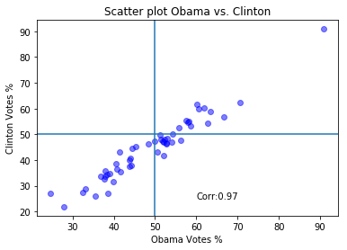

1. Change in unemployment rate, change in median home prices and change in payroll did not have any effect in election results.

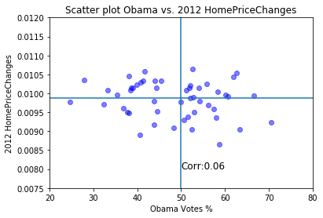

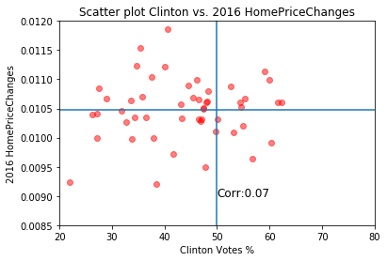

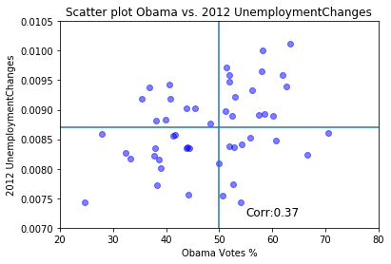

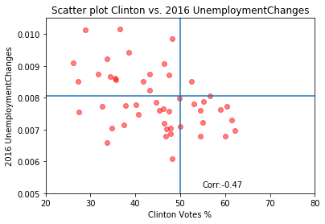

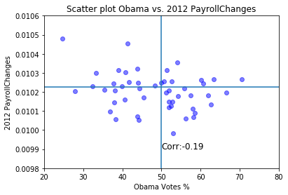

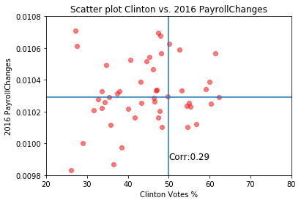

1. There are certain states that will never vote for a Democrat and there are certain states that will never vote for a Republican and it is few states that determine the election results.